Year 1 Phonics
Phonics Play is currently free. It has games and activities suitable for our learners. 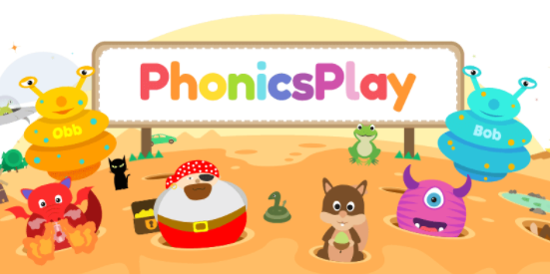
https://www.phonicsplay.co.uk
Username: jan21
Password: home
Lesson 1 – Monday 11th January
ay sound as in ‘May I play?’
- Watch the video and join in with the teacher: https://www.youtube.com/watch?v=6cc7xQ_R4_4
- Practise reading and writing words with the ay sound in them. Use your neatest handwriting!
day, play, may, say, stray, clay, spray, tray, crayon, delay
- Try reading these sentences. Watch out for the similar sound ai (snail in the rain!)
The rain went in the tray.
We play in the train.
The spray hit the sail.

Lesson 2 – Tuesday 12th January
ie sound as in ‘a tie in a pie’
- Watch the video: https://www.youtube.com/watch?v=DoPUHeA0CHA
Geraldine the Giraffe found objects at home with the ie sound in their names.
- Can you read and spell these words too? Ask an adult to help you by telling you which one to spell without looking!
pie cried tried replied lie fried denied tied spied
- Write a sentence with some of the words in. Remember capital letter, finger spaces and a full stop! Challenge: extend your sentence with and, but or because.
E.g. The little boy cried because he hurt his toe.
I ate an apple pie but I didn’t have custard.
She tied the kite on the string and flew it high in the air.

Lesson 3 – Wed 13th Jan
i_e (Split digraph) as in ‘Nice smile!’
- Watch the video: https://www.youtube.com/watch?v=xhzuQIVgyak
- Read these sentences. Watch out for the same sound written as igh.
You have got a nice bright smile.
The time was right.
The prize was a nice sight.
- Can you think of any other words with the igh, ie or i_e sound in? Make a list in your neatest handwriting.

Lesson 4 – Thursday 14th Jan
o_e (Spilt digraph) as in ‘Phone home’
- Watch the video: https://www.youtube.com/watch?v=HF8bMZXmScU (There are a few sounds at the start of the video that we haven’t done yet – don’t worry!)
- Read and spell these words:
bone, home, alone, those, stone, woke, note, explode, envelope
- Write a sentence with some of these words in. Challenge: extend your sentence with and, but or because.

Lesson 5 – Friday 15th Jan
- Watch the Alphablocks video. They’re spelling the same sound in lots of different ways: oa, oe and o_e https://www.youtube.com/watch?v=UQFilBxEseg
- Play Obb and Bob https://www.phonicsbloom.com/uk/game/odd-and-bob?phase=5#
Click on o-e.
Sort the words and decide if they are real or fake.
You could practise some of the other sounds on this game too!

