
Let’s Get Reading!

Every day we want you to read a book from Oxford Owl. You will need to set up a parent account but this is free.
Follow these instructions.

- Type into google
https://www.oxfordowl.co.uk/

- Click on Oxford Owl for Home. It looks like this
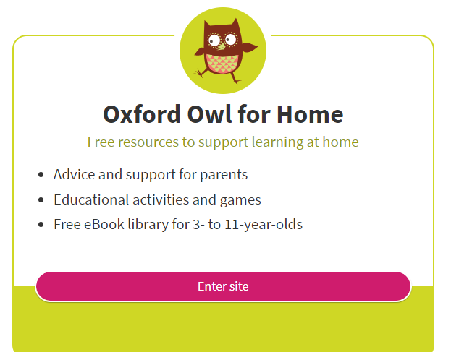
- Click on Browse e books. It looks like this
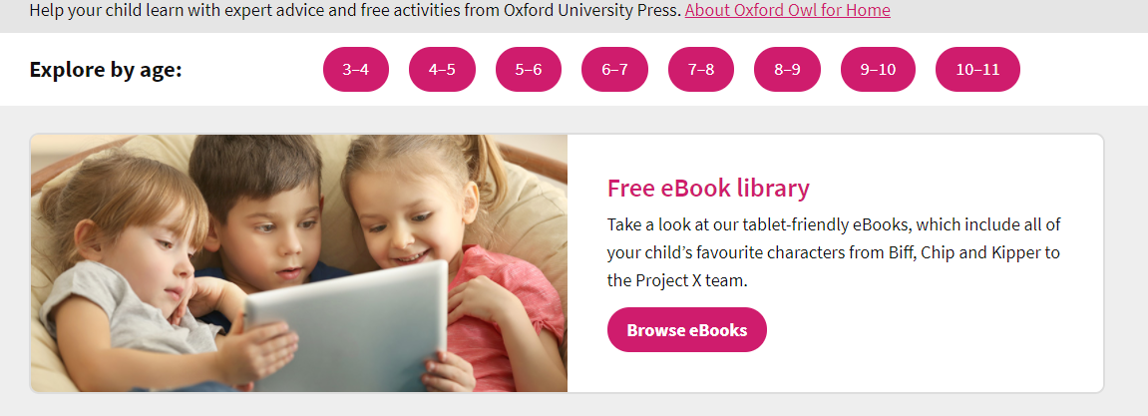

- Click on browse the e book library. It looks like this.
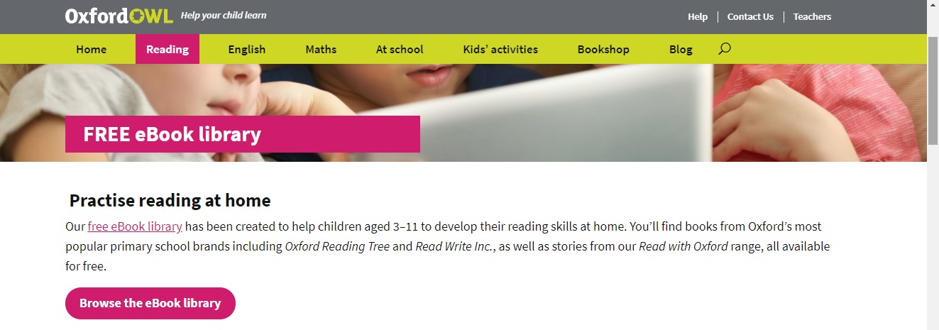

CLICK ON THIS

- Click on browse by Levels. It looks like this.
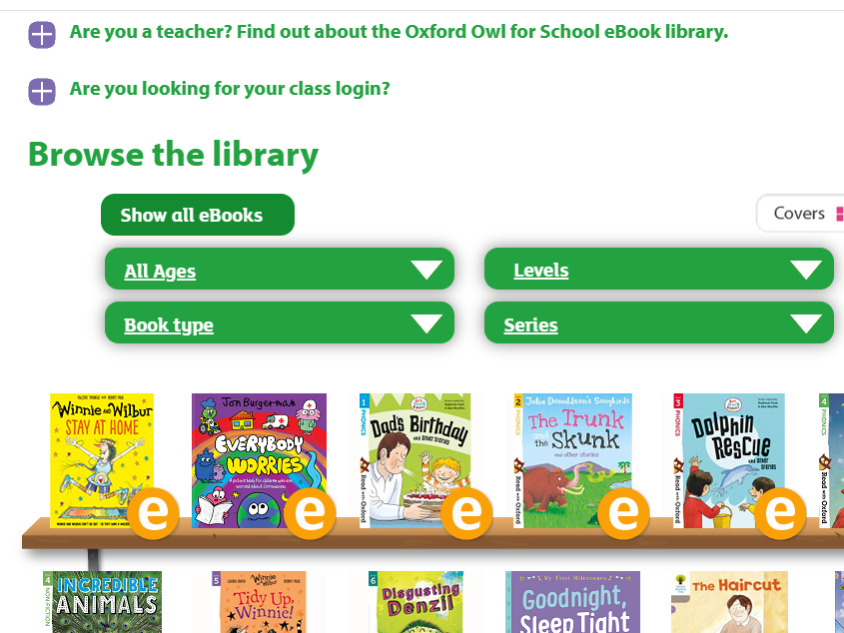 Click this

- Click on book bands. It looks like this. 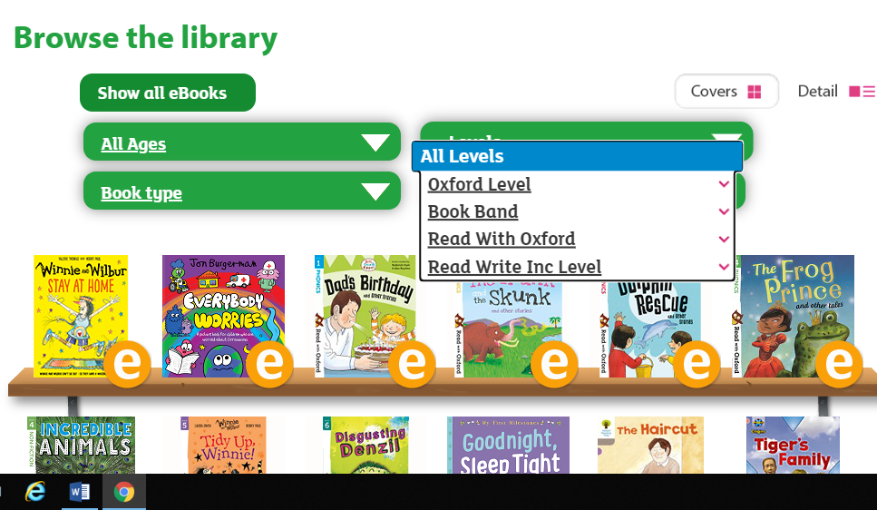
- Find your child’s book level that is on their home reading book. (They should know what number book they read). If you choose a different one it may be too hard or easy for them to read.
It looks like this
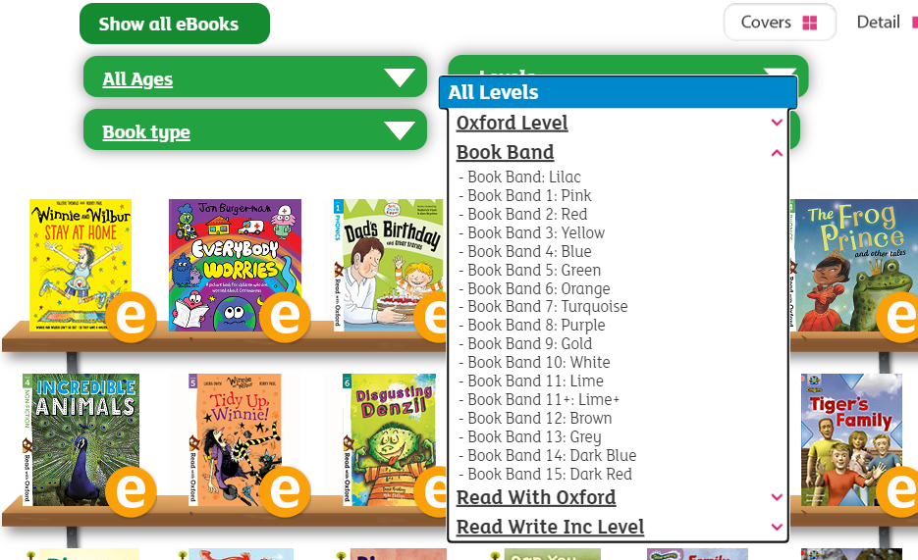

- Choose a book that you want to read. It will look something like this. There will be different books that you will see depending on your level.
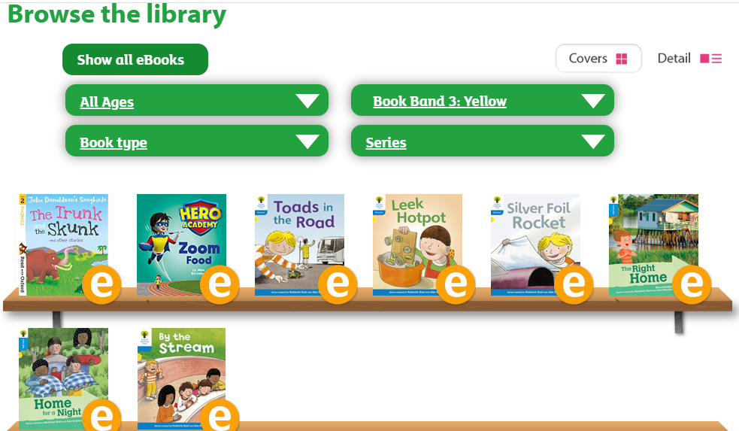

Write down the title of the book that you read each day.
Day 1_____________________________________
Day 2_____________________________________
Day 3_____________________________________
Day 4_____________________________________
Day 5_____________________________________

Have fun reading!

