The progression of knowledge in the Foundation Stage is set into a broad timeframe. Whilst the order of knowledge acquisition is followed, there is an understanding that children may develop and progress at varying rates.
Autumn | 1 | Handwriting  Experiments with mark making inside and outside e.g. with water and rollers, chalks, felts and paint. | RANGE 5  Know how to hold a mark making tool using a tripod grip  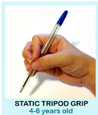  Static tripod grip  This is a 3 finger grasp, where the thumb index finger and middle finger work as one unit.  Know that when a pen and pencil is pulled along a paper it leaves marks  Know what they have drawn or painted and can express this in simple terms  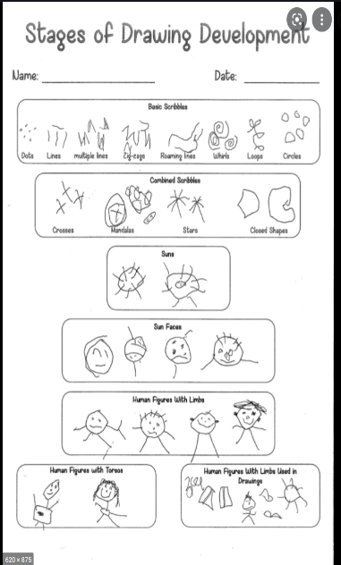  Know how to draw a picture of their family, uses sun faces with limbs  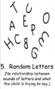  Know how to make lines and circles. Knows movement concepts: up, down, around  Know how to copy letters from their name and other important letters to them.  Know how to write own name  Know how to write letters shapes explicitly taught in phonics  Physical Development  Pencil Control  • know how to hold a pencil with 3 fingers in a tripod grip to write  • know the dominant hand.  • know that all letters are formed starting from the top | Spelling  Apply phonic knowledge in writing with increasing independence and reflecting the phonic phase currently attained.  Grammar  Use basic sentence punctuation eg. capital letters and full stops.  Use capitalisation for people and place names.  Handwriting  Secure letter formation.  Composition  Orally rehearse simple sentences before writing and evaluate for sense and clarity.  Write a sequence of sentences to form a short narrative. | Spelling  Spell by segmenting spoken words into phonemes, reflecting phonic attainment.  Spell some common exception words from the Year Two word list.  Grammar  Use coordination using ‘and’.  Use expanded noun phrases for description.  Use present and past tense with increasing accuracy.  Mostly use capital letters and full stops correctly.  Begin to use suffix -er and -ed to spell words correctly.  Handwriting  Form lower case and capital letters of the correct size relative to one another. Use the correct orientation.  Using spacing between words that reflect the size of the letters.  Composition  Think about what is going to be written by planning or saying aloud.  Write from memory simple sentences dictated by the teacher that include words using the GPCs, common exception words and punctuation taught so far.
Autumn | 2 | Handwriting  Sometimes give meaning to their drawings and paintings. | RANGE 5  Knows how to write own name  Know how to make and add writing to greeting cards using graphemes learnt so far in phonics  Know how to make marks, lines, circles using touch screen technology to make a firework picture  Know how to write CVC words by listening to the first, second and last sound in a word using Fred Fingers  Draw specific parts of stories they recall for Owl babies/ Whatever Next!/ Peace at last  Know how to mark make for a range of purposes, greeting cards, shopping lists and labels for construction models  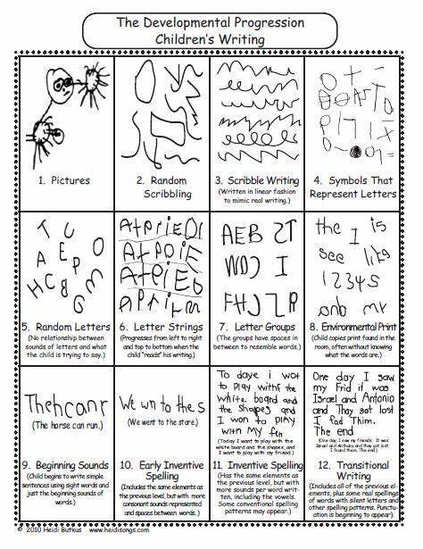  Physical Development  Pencil Control  • know that letters are formed from the top.  • know that some letters are formed using an anti-clockwise movement. | Spelling  Apply phonic knowledge in writing with increasing independence and reflecting the phonic phase currently attained.  Grammar  Use basic sentence punctuation eg. capital letters and full stops.  Use capitalisation for people and place names.  Beginning to use simple prefixes and suffixes such as -ing and -ed  Handwriting  Secure letter formation.  Composition  Orally rehearse simple sentences before writing and evaluate for sense and clarity.  Write a sequence of sentences to form a short narrative. | Spelling  Spell by segmenting spoken words into phonemes, reflecting phonic attainment.  Spell some common exception words from the Year Two word list.  Grammar  Use coordination using ‘and’ and ‘but’.  Use expanded noun phrases for description.  Use present and past tense with increasing accuracy.  Mostly use capital letters and full stops.  Handwriting  Form lower case and capital letters of the correct size relative to one another. Use the correct orientation.  Using spacing between words that reflect the size of the letters.  Composition  Consider what is going to be written before beginning by writing down ideas and key words including new vocabulary.  Write about real events simply and clearly.  Begin to write a short narrative coherently.
Spring | 1 | Handwriting  Distinguishes between the different marks they make.  Enjoys drawing and writing on paper, on screen and on different textures, such as in sand or playdough and through using touch-screen technology. | RANGE 6  Know how to write CVC words by listening to the first, second and last sound in a word using Fred Fingers  Know to write all the sounds heard in a word than leave a finger space, before writing the next word  Know how to hold a simple sentence and write it  Draw a specific part of stories they recall for Jack Frost/Ridiculous/Lost and Found  Know how to mark make for a range of purposes, greeting cards, recipes, shopping lists and labels for construction models  Label a picture using initial sounds, a middle and an end sound  Know how to draw a picture of their family, human figures with torsos  Know how to write some common exception words: no I go to the of my for he  Physical Development  Pencil Control  • know that some letters are formed using an anti-clockwise movement.  • know how to retrace vertical lines to form letters  • know how to form some letters correctly | Spelling  Apply phonic knowledge in writing with increasing independence and reflecting the phonic phase currently attained.  Spell some common exception words from the Year One word list.  Grammar  Use appropriate spacing and basic sentence punctuation, including capital letters and full stops  Beginning to use simple suffixes such as -ing and -ed  Handwriting  Secure letter formation.  Composition  Orally rehearse simple sentences before writing, evaluating for sense.  Write sequences of simple sentences for different purposes.  Use ‘and’ as a conjunction to construct compound sentences.  Include adjectives in simple sentences. | Spelling  Spell by segmenting spoken words into phonemes, reflecting phonic attainment.  Spell some common exception words from the Year Two word list.  Grammar  Use coordination using ‘and’ and ‘but’.  Use some subordination with ‘because’, ‘if’.  Use expanded noun phrases for description.  Use present and past tense mostly accurately.  Use apostrophes to mark singular possession in nouns e.g. the girl’s name.  Add suffixes to spell some longer words correctly including -ful  Write different types of sentences – statements, questions and commands for effect.  Handwriting  Form lower case and capital letters of the correct size relative to one another. Use the correct orientation.  Using spacing between words that reflect the size of the letters.  Composition  Plan what will be written, sentence by sentence.  Make simple additions, revisions and corrections to their work by proof reading. E.g. checking spellings, grammar and punctuation or improving words and phrases.
Spring | 2 | Handwriting  Gives meaning to marks they make as they draw and paint. | RANGE 6  Know how to write CVC words by listening to the first, second and last sound in a word using Fred Fingers  Know to write all the sounds heard in a word then leave a finger space, before writing the next word  Know how to hold a simple sentence and write it  Draw own story map of specific parts of stories they recall for Mr Gumpy’s motor car/Monkey Puzzle  Know how to mark make for a range of purposes, greeting cards, recipes, shopping lists and labels for construction models  Know how to draw a map with simple landmarks with labels  Know how to write some common exception words: no I go to the of my for he we was  Physical Development  Pencil Control  • know that some letters are formed using an anti-clockwise movement.  • know how to retrace vertical lines to form my letters  • know how to form some of my letters correctly | Spelling  Apply phonic knowledge in writing with increasing independence and reflecting the phonic phase currently attained.  Spell some common exception words from the Year One word list.  Grammar  Use appropriate spacing and basic sentence punctuation, including capital letters and full stops and using capitalisation for names of people and places.  Beginning to use simple prefixes such as -un  Handwriting  Secure letter formation.  Composition  Orally rehearse simple sentences before writing, evaluating for sense and clarity and looking for ways to improve. Begin to create simple drafts  Write sequences of simple sentences for different purposes.  Include adjectives in simple sentences.  Use ‘and’ as a conjunction to construct compound sentences. | Spelling  Spell by segmenting spoken words into phonemes, reflecting phonic attainment.  Spell some common exception words from the Year Two word list.  Grammar  Use coordination with ‘and’, ‘or’ and ‘but’.  Use some subordination with “when”, “because”, “if”.  Use expanded noun phrases for description.  Use present and past tense mostly accurately.  Use apostrophes to mark singular possession in nouns e.g. the girl’s name.  Handwriting  Form lower case and capital letters of the correct size relative to one another. Use the correct orientation.  Using spacing between words that reflect the size of the letters.  Composition  Plan what will be written, sentence by sentence.  Make simple additions, revisions and corrections to their work by proof reading. E.g. checking spellings, grammar and punctuation or improving words and phrases.
Summer | 1 | Spelling  Hears and says the initial sound in words.  Handwriting  Attempts to write their own name, or other names and words, using combinations of lines, circles and curves, or letter-type shapes. | RANGE 6  Know how to write CVC words by listening to the first, second and last sound in a word using Fred Fingers  Know to write all the sounds heard in a word then leave a finger space, before writing the next word  Know how to hold a simple sentence and write it  Draw own story map of specific parts of stories they recall for Jack and the Beanstalk/The Three Billy Goat Gruff/The Three Little Pigs  Know how to mark make for a range of purposes, greeting cards, recipes, shopping lists and labels for construction models  Know how to write some common exception words: no I go to the of my for he we was  Physical Development  Pencil Control  • know that some letters are formed using an anti-clockwise movement.  • know how to retrace vertical lines to form letters  • know how to form most letters correctly | Spelling  Apply phonic knowledge in writing with increasing independence and reflecting the phonic phase currently attained.  Spell many common exception words from the Year One word list.  Spell plurals using ‘s’ and ‘es’.  Grammar  Use capital letters, full stops to demarcate sentences.  Begin to recognise and use exclamation marks.  Handwriting  Secure letter formation.  Composition  Orally rehearse simple sentences before writing, evaluating for sense and clarity and looking for ways to improve. Begin to create simple drafts  Write sequences of simple sentences for different purposes.  Use ‘and’ as a conjunction to construct compound sentences  Include adjectives in simple and compound sentences.  Write sequences of sentences to form short narratives.  Reread and check writing for sense. | Spelling  Segment spoken words into phonemes and represent these by graphemes, spelling many of these words correctly and making phonically plausible attempts at others.  Add suffixes to spell some longer words correctly including –ly.  Grammar  Demarcate most sentences in their writing with capital letters and full stops and exclamation marks correctly when required.  Use present and past tense mostly correctly and consistently.  Use co-ordination and some subordination to join clauses.  Write different types of sentences – statements, questions, exclamations and commands for effect.  Spell most common exception words.  Spell some words with the contracted form.  Use and understand grammatical terminology.  Handwriting  Use some diagonal and horizontal strokes needed to join letters and understand which letters, when adjacent to one another and to lower case letters.  Composition  Write simple, coherent narratives about personal experiences and those of others (real or fictional).  Write about real events, recording these simply and clearly.  Plan what will be written, sentence by sentence.  Make simple additions, revisions and corrections to their work by proof reading. E.g. checking spellings, grammar and punctuation or improving words and phrases.  Read aloud what they have written with appropriate intonation to make the meaning clear.
Summer | 2 | Spelling  Hears and says the initial sound in words.  Handwriting  Begins to make letter type shapes to represent the initial sound of their name and other familiar words.  Learn how to use mark making and early writing in their play. | RANGE 6  Know how to write CVC words by listening to the first, second, and last sound in a word using Fred Fingers  Know to write all the sounds heard in a word then leave a finger space, before writing the next word  Know how to hold a simple sentence and write it  Draw own story map of specific parts of stories they recall for Tiddler / Shark in the Park!  Know how to mark make for a range of purposes, greeting cards, recipes, shopping lists and labels for construction models  Know how to write some common exception words:  no I go to the of my for he we was me  Physical Development  Pencil Control  • know how to form most letters correctly. | Spelling  Words containing each of the 40+ phonemes are mostly correctly spelt.  Evidence of more than one plausible grapheme choice for some phonemes even if not accurate.  Most common exception words are spelt accurately.  The suffixes ing, ed, s, es er & est and the prefix un are mostly used accurately.  Days of the week are mostly spelt correctly.  Use of the pronoun I is mostly correct.  Grammar  Capital letters and full-stops are sometimes accurate.  Within sentences, some words and clauses are joined using ‘and’ demonstrating understanding that ideas can be joined.  Capital letters and full-stops are sometimes accurate.  Question marks and exclamation marks are occasionally used correctly in writing.  Handwriting  Lower and upper-case letters are mostly formed accurately, starting and finishing in the correct place.  Finger spaces are used.  Composition  Sentences are sequenced to form short narratives.  Writing communicates meaning through simple sentences.  Children can read their own words or sentences out loud to check that they makes sense. | TAF  Spelling  Segment spoken words into phonemes and represent these by graphemes, spelling many of these words correctly and making phonically plausible attempts at others.  Spell most common exception words.  Add suffixes to spell most words correctly in their writing.  Grammar  Demarcate most sentences in their writing with capital letters and full stops, and use question marks correctly when required. Use present and past tense mostly correctly and consistently.  Use co-ordination (e.g. or / and / but) and some subordination (e.g. when / if / that / because) to join clauses.  Use the punctuation taught at key stage 1 mostly correctly.  Handwriting  Form capital letters and digits of the correct size, orientation and relationship to one another and to lower-case letters. Use spacing between words that reflects the size of the letters.  Use the diagonal and horizontal strokes needed to join some letters.  Composition  Write simple, coherent narratives about personal experiences and those of others (real or fictional).  Write about real events, recording these simply and clearly.  Write effectively and coherently for different purposes, drawing on their reading to inform the vocabulary and grammar of their writing.  Make simple additions, revisions and proof reading corrections to their own writing.

