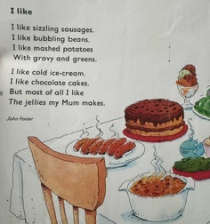
Year 1 – Medium term planning Poetry - I like By John Foster
From Oxford Reading Tree.

Reading activities | Smaller writing tasks | Outcome | Punctuation, grammar, vocab, sentence types | Spellings and handwriting
Whole class input:  Reading – read the poem  Spot patterns in the poem. Verses start with ‘I like’, rhyming pairs: beans -greens, cakes-makes.  STAR vocab: gravy  Poem talk – questions to aid understanding of the poem. | N/A | Present tense  Simplified poem that have verses which start with ‘I like’ and finishes with ‘but most of all I like….  No rhyming words are necessary or commas.  Eg: MAPS ability:  I like jam.  I like ham.  I like …  I like …  I like cake.  I like ice cream.  I like …  I like …  But most of all I like … | Punctuation:  Introduce capital letter ‘I’  Full stops  Finger spaces  Grammar:  Adjective – from prior learning for HAPs.  Sentence type:  Verses  Vocabulary:  Adjectives (size and colour) for HAPs. | CEW: I, like, the  Handwriting size – ascenders to be written taller (almost touching the top line)

