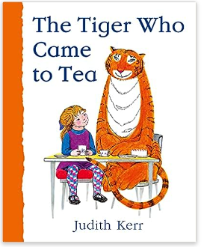
Year 1 – Medium term planning - The Tiger Who Came to Tea By Judith Kerr
Shopping list, Character description and retell of a specific part of the story.

Reading activities | Smaller writing tasks | Outcome | Punctuation, grammar, vocab, sentence types | Spellings and handwriting
Hook  Read book.  STAR vocab: ring, grocer -show a picture of Pak foods as they have been on local walk, tiger, cafe  Hold a sentence: Vary for ability groups.  Book talk: Who? What? Where? Questions. | 1)Teach -s and es.  Sandwiches, buns, packets, tins, sausages, chips,  Sophie and her mummy went shopping. Write a shopping list using s and es.  Eg: buns, tins of soup, chips, packets of sweets, chocolates, pears, bananas, jams, beans, peaches, boxes of tiger food.  Character description of tiger. -label tiger with adjectives and noun. Eg: long tail. Use this to write description-  Eg: He had four legs. He had orange fur. He had a (long) tail. | Past tense  Retell part of the story. Give spelling ‘ate’.  Eg:  The big tiger pressed the bell. Sophie said come in. He was hungry. He opened the boxes of cereal. He found tins of peaches/soup. He ate some chips and all the buns. He munched the sweets… | Punctuation:  Full stops  Capital letters for start of sentences and people.  Finger spaces  Grammar:  ‘and’ compound sentence.  Suffix -s and es words  Sentence type:  Statements  Vocabulary:  Suffix -s and es  Adjectives colour and size | CEW: come, he, some  Write day of the week at the beginning of the session, before writing session starts.  Handwriting size – follow handwriting scheme  Apply phonic knowledge reflecting the phonic phase currently attained.
HAPS

