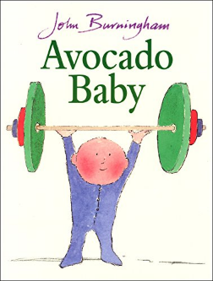
Year 1 – Medium term planning - Avocado Baby By John Burningham
Character description and retell.

Reading activities | Smaller writing tasks | Outcome | Punctuation, grammar, vocab, sentence types | Spellings and handwriting
Hook - tasting of avocado  Read book.  STAR vocab: weak, wailed, avocado pear (show real object), cart, cot, burglar, leapt, furniture, bully.  Hold a sentence: Vary for ability groups.  Book talk: Who? What? Where? Questions. How did the avocado get there? How did the mum feel at the start of the story? Etc.  Story map – draw as a class. Draw all parts of the outcome->-> | 1)Teach -ed words -where there is no change in the root word (pulled, wailed, mashed, played, opened, pushed…)  Write these up in sentences.  The baby _____ the _______  Eg: The mum mashed the  avocado.  2)Character description of mum or baby.  Eg: Mum has…Mum is… | Past tense  Retell of the story in simple terms.  Eg:  The family were weak. Mum had a baby. The baby did not like milk. The baby was weak.  ---------------------------------Mum fed the baby avocado. The baby got strong. The baby pulled the cart uphill. He grabbed the cot. He pushed the car. He pushed the bully in the pond.  The baby was strong.  As always the outcome must be differentiated – LAPs and MAPs could write part of the story or write whole story in 3-4 sentences. HAPs- could write their own ideas of what the strong baby did (innovate). | Punctuation:  Full stops  Capital letters for start of sentences.  Finger spaces  Grammar:  ‘and’ compound sentence.  Suffix -ed words  Sentence type:  Statements  Vocabulary:  Suffix -ed | CEW: he, she, push(ed), pull(ed)  Spelling -y  Baby, bully, very, family, nasty.  Write day of the week at the beginning of the session, before writing session starts.  Handwriting size – follow handwriting scheme  Apply phonic knowledge reflecting the phonic phase currently attained.
HAPS

