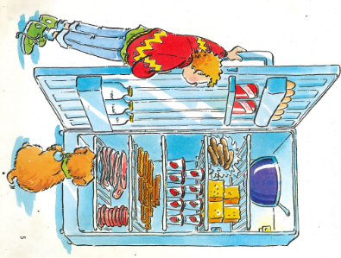
Year 1 – Medium term planning - I went to the Fridge By John Foster
Poetry

Reading activities | Smaller writing tasks | Outcome | Punctuation, grammar, vocab, sentence types | Spellings and handwriting
Hook – Teacher to recite poem with photos of the food found in the fridge as an aid, maybe display on a ppt.  STAR vocab: chunks, large, slices – photos of these chunks of cheese etc can be discussed.  Poem talk- What did the person find in the fridge? Discuss what compound words are. Highlight compound words in the poem. | Practice writing numbers in words (one, two, three, four, five…ten.  Adjectives (size and colour) -briefly  Discuss compound words from poem – blackcurrent, strawberry, beefburger. | Past tense  Writing in the style of the poet.  Write a poem about what was found in the teachers cupboard/box/backpack.  (have items on display- whiteboard, lunchbox, teapot, football, backpack etc. as stimulus)  Eg:  10 mini whiteboards  9 black footballs  MAPs and LAPS:  5 whiteboards  4 teapots  3 footballs  2…  1… | Punctuation:  Capital letters for start of verse  Finger spaces  Grammar:  -  Sentence type:  Verse  Vocabulary:  Numbers in words  Adjectives  Compound words | CEW: to, the, saw, he, we, be, she, me  Write day of the week at the beginning of the session, before writing session starts.  Handwriting size – follow handwriting scheme  Apply phonic knowledge reflecting the phonic phase currently attained.
HAPS

