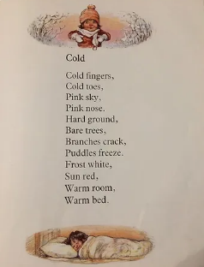
Year 2 – Medium term planning Poetry - Cold By Shirley Hughes

Reading activities | Smaller writing tasks | Outcome | Punctuation, grammar, vocab, sentence types | Spellings and handwriting
Whole class input:  Reading – read the poem  Spot patterns in the poem. Each line consists of only two words, rhyming pairs: toes -nose, trees - breeze, red - bed.  Discuss use of commas.  STAR vocab: bare  Poem talk – questions to aid understanding of the poem. | As a class go outside and brainstorm. | Present tense  Short poem that has lines two words long. Describe outdoors on an autumnal day in September.  No rhyming necessary.  Commas.  Eg: MAPS ability:  Warm fingers,  Warm nose,  Green leaves,  Green grass. | Punctuation:  Capital letters  Full stops  Finger spaces  Commas  Grammar:  Adjective  Sentence type:  Verses  Vocabulary:  Adjectives (size and colour) | CEW: old, cold, break, grass, pretty  Handwriting size – ascenders to be written taller (almost touching the top line)

HAPs extension highlighted in yellow.



