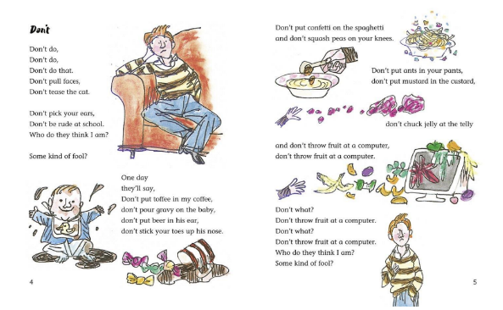
Year 2 – Medium term planning - Don’t by Michael Rosen
Poetry – 1 week.

Reading activities | Smaller writing tasks | Outcome | Punctuation, grammar, vocab, sentence types | Spellings and handwriting
Hook – watch poet in action ‘Don’t Michael Rosen’ youtube.  STAR vocab: fool, gravy, beer, confetti, spaghetti, mustard, custard, telly  Groups of children practice a verse chorally. Put verses together to complete the recital, record this and play back to the children the following day. iPad needed. (adapt for your ability set)  Poem talk- How does the boy feel? Why is he moaning? Do your grown-ups tell you not to do things at home? What about your teachers!? | Poem plan with vocab- not the whole poem but a section of the poem.  Rhyming pairs, generate rhyming pairs as a class  Prepositions: ‘on the’, ‘in the’, ‘up the’, ‘at the’ | Past tense  Write a poem using plan, in the style of the poet. | Punctuation:  Question marks  Finger spaces  Grammar:  Contractions – they’ll, don’t  Sentence type:  Question  Verse  Vocabulary:  Rhyming pairs | CEW: -  Write the long date at the top of the page.  Handwriting:  Capital letters and corresponding lowercase letters. (4 lower case letters and their corresponding capital letters)  Apply phonic knowledge reflecting the phonic phase currently attained.
HAPs

