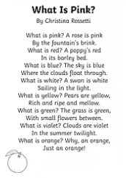
Year 2 – Medium term planning Poetry – What is Pink? By Christina Rossetti
1 week

Reading activities | Smaller writing tasks | Outcome | Punctuation, grammar, vocab, sentence types | Spellings and handwriting
Reading – read the poem and see animated version on Youtube.  STAR vocab: brink, barley bed, summer twilight.  Poem talk – questions to aid understanding of the poem. | Teach - homophones and near homophones. Generate homophones and near homophones. (Activity idea- give each child a word on a piece of paper and children go around reading them and finding their homophone partner.)  To/two/too  Son/sun  Blue/blew  Be/bee  Sea/see  Bare/bear  Can they find more in a piece of text/poetry? See poem ‘To be or not to bee’ – don’t have to use it. | Write a simplified poem describing the colours. No need to include rhyming verses. Must include the correct homophones spelling using a class display?  Eg:  What is blue?  The sky is blue…  What is yellow?  A bee is yellow…  What is brown?  A tree is brown, tall and bare. | Punctuation:  Capital letters  Finger spaces  Question marks  Grammar:  Homophones and near homophones  Sentence type:  Verse  Questions  Vocabulary:  Rhyming pairs (recap only)  Adjectives (prior knowledge)  Homophones and near homophones | Handwriting:  Capital letters and corresponding lowercase letters. Use horizontal and diagonal strokes needed to join some letters.  Apply phonic knowledge reflecting the phonic phase currently attained.

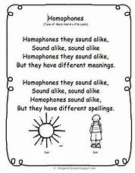

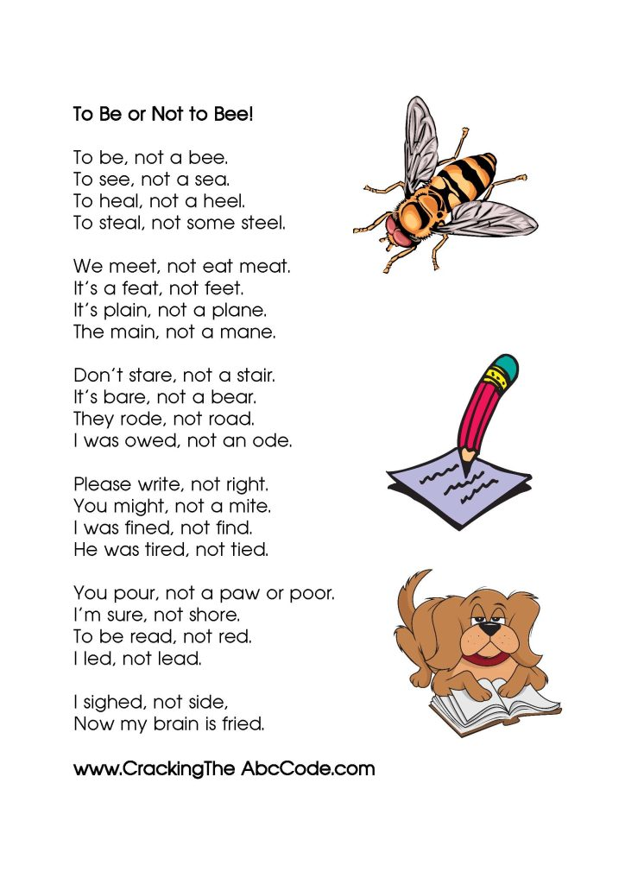(If you want to use it.)

