
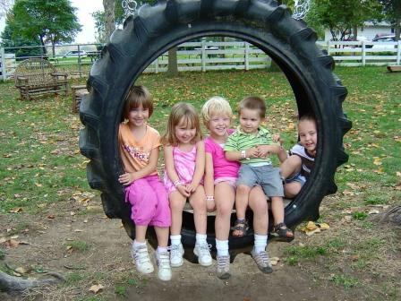


Child Friendly

Safeguarding Policy
The right to be educated
The right to be treated fairly


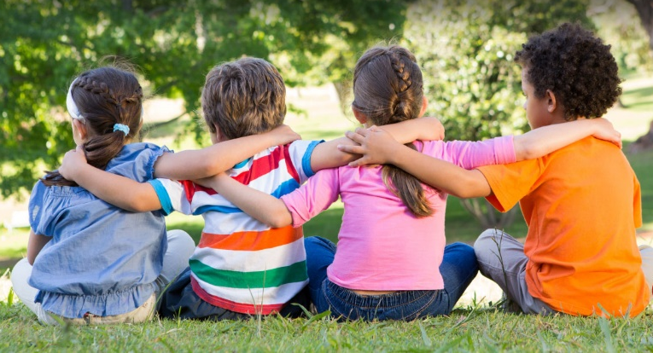
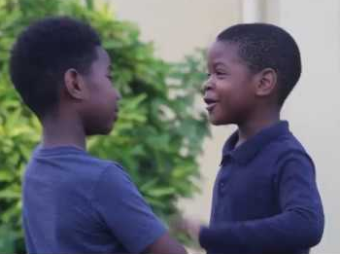
The right to be heard
The right to a childhood
The right to be educated

The right to be educated

Safeguarding at Merrydale Infant School
Our school has a safeguarding policy for staff, families and governors. This child friendly policy is designed for you. We created this policy to help you decide what could be a ‘problem’ and where to get help and support.
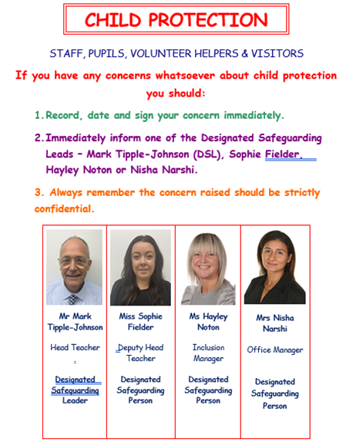
There may be times when you want to talk to someone in school about a problem that might be upsetting you. We have people in school who are specially trained to help you, it is important that you know where to get help if you are worried or unhappy about something:-
Safeguarding means that all staff will:-
- Protect you from harm
- Make sure nothing stops you from being happy
- Make sure you are safely looked after
- Make sure you have the best life chances

There are lots of other people too, who may help you with an upsetting problem and they do not work at your school but care about you just as much as we do.

Has someone touched you on a part of your body like your bottom or chest or anywhere else you do not like?
Is someone bullying you? Is this happening
every day?

Has someone said something to you that upsets you?

Stay safe when using a mobile phone or the internet. If someone you don’t know tries to speak to you or someone shows you a video or photo that makes you feel uncomfortable then TELL SOMEONE!

DO NOT be scared to tell
Someone. We will always listen!
You must tell someone at school so we can help you. You can tell:-

- The Teachers
- The Headteacher
- The Teaching Assistants
- Your Dinner Ladies
- The Cleaners
- Designated Safeguarding Leads

Is someone trying to give tablets, cigarettes, drugs or alcohol?
Has someone hit, punched or smacked you or hurt you in anyway?

Do NOT keep it a Secret!

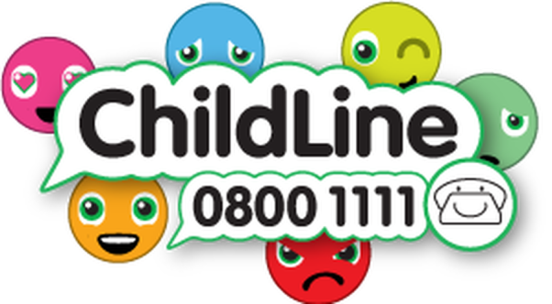
Other places that may be able to help you:
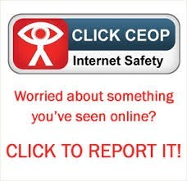
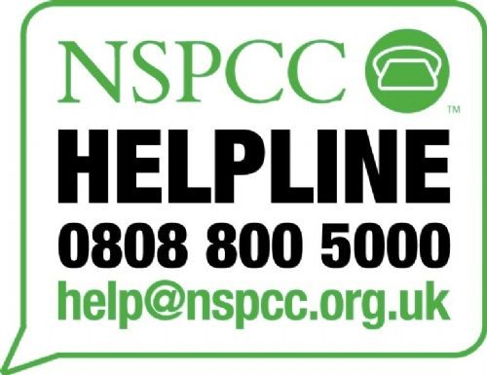

Stay safe when using a mobile phone or when using the internet. If someone you don’t know tries to speak to you or someone shows you a video or photo that makes you feel uncomfortable then tell someone!


